**MUNICIPALITY REGISTRATION**

**67% Completed**

|  |  |  |  |  |  |  |  |  |  |  |  |  |  |  |  |  |  |  |  |  |  |  |  |  |  |  |  |  |
| --- | --- | --- | --- | --- | --- | --- | --- | --- | --- | --- | --- | --- | --- | --- | --- | --- | --- | --- | --- | --- | --- | --- | --- | --- | --- | --- | --- | --- |
| |  |  | | --- | --- | | 1. **MUNICIPALITY NAME & CONTACT DETAILS** *Figure 1* | | | **Municipality Name\*** |  | | **E-Mail Address\*** |  | | **Contact Number\*** |  | | **FAX Number\*** |  | | **Indicator\*** | |  |  |  | | --- | --- | --- | |  |  |  | | | |  |  | | --- | --- | | 1. **MUNICIPALITY ADDRESS**  *Figure 2* | | | **Street Name\*** |  | | **Town / City\*** |  | | **Province\*** |  | | **Municipal Code\*** |  | | **GPS Coordinates\*** |  | |

1. **ADD 3 X COORDINATORS\*** *Figure 3*

|  |  |  |  |  |  |
| --- | --- | --- | --- | --- | --- |
|  | **Name** | **Surname** | **Position** | **Contact** | **E-Mail** |
|  |  |  |  |  |

1. **ADD PROJECT MANAGER\*** *Figure 4*

|  |  |  |  |  |  |
| --- | --- | --- | --- | --- | --- |
|  | **Name** | **Surname** | **Position** | **Contact** | **E-Mail** |
|  |  |  |  |  |

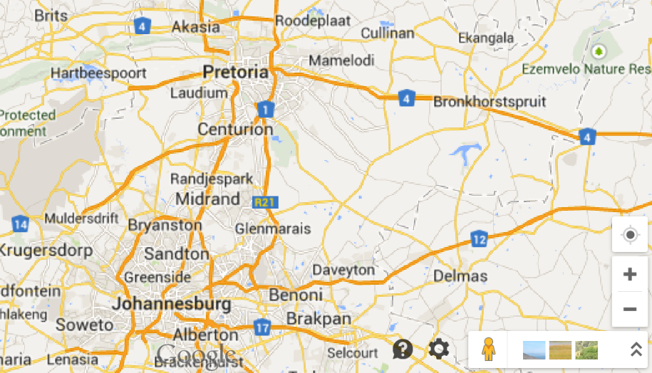

1. **UPLOAD LEGAL DOCUMENTATION** *Figure 5*

|  |  |  |
| --- | --- | --- |
|  | **Document uploaded** | **Date** |
| Council resolution* |  |  |
| Memorandum of Agreement* |  |  |

1. **UPLOAD FINANCE DOCUMENTATION** *Figure 6*

|  |  |  |
| --- | --- | --- |
|  | **Document uploaded** | **Date** |
| Envelope* |  |  |
| Current year Gazette* |  |  |

**SAVE**

**EDIT**

*Figure 8 Figure 9*

**MAP** *Figure 7*

**MUNICIPALITY FUNCTIONALITY TABLE (Data)**

|  |  |  |  |  |
| --- | --- | --- | --- | --- |
| **FIGURE** | **FUNCTIONALITY** | **WORKFLOW** | **BUSINESS RULES** | **MILESTONES** |
| 1. MUNICIPALITY NAME & CONTACT DETAILS *Figure 1* | Data to be captured into fields and saved to Database | None | Force fields must be completed | Registration of Muni |
| 2. MUNICIPALITY ADDRESS *Figure 2* | Data to be captured into fields and saved to Database | None | Force fields must be completed | Registration of Muni |
| 1. ADD 3 X COORDINATORS* *Figure 3* | 3 x Coordinators details to be captured into the fields and saved into the database | None | Force fields must be completed | Registration of Muni |
| 1. ADD PROJECT MANAGER* *Figure 4* | Project manager details to be captured into the fields and saved into the database | Project Manager to be notified on the allocation via e-mail | Force fields must be completed | Registration of Muni |
| 1. UPLOAD LEGAL DOCUMENTATION *Figure 5* | Documentation to be uploaded into the file plan | Project Manager to be notified on the upload of legal documentation via e-mail | Force fields must be completed | Registration of Muni |
| 1. UPLOAD FINANCE DOCUMENTATION Figure 6 | Documentation to be uploaded into the file plan | Project Manager to be notified on the upload of financial documentation via e-mail | Force fields must be completed | Registration of Muni |
| 1. MAP *Figure 7* | Google map to be provided indicating the area | None | None | None |
| 1. SAVE Button *Figure 8* | Save all data and documentation captured into the database or file plan. | Project Manager to be notified on the registration information complete | None | None |
| 1. EDIT Button *Figure 9* | Municipality information can be edited | Project Manager to be notified on the registration information edited and saved | None | None |